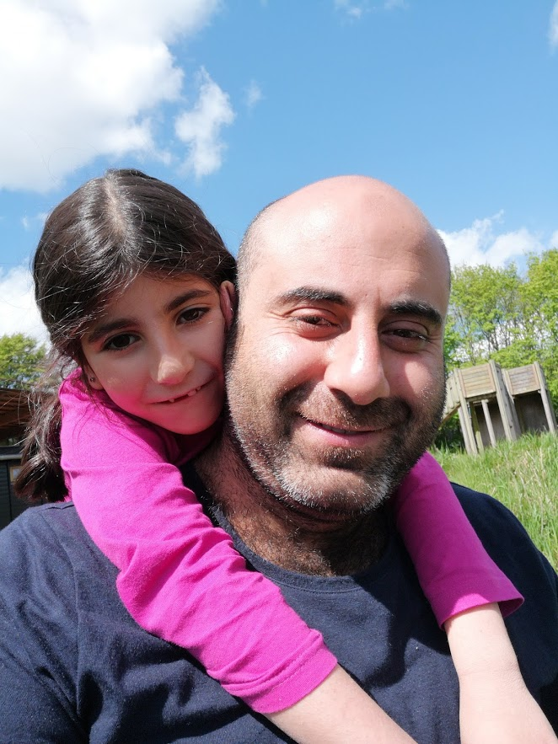

DAP1

Final Exam Report

By

Taha Alzein

269055@via.dk

**Teacher:** René Birkholm, tegneren.dk

Friday, 24th MAY 2019

# Turntable Animation

<https://youtu.be/ms5CI5uEHcA>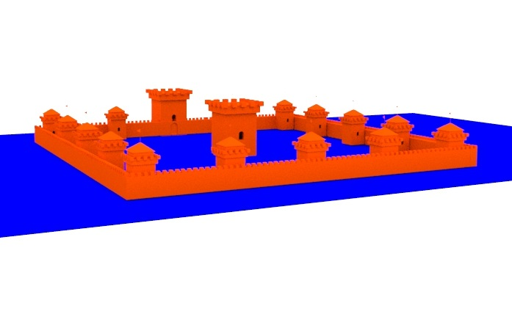

A polygons primitive is used to build the castle, a gates and windows are made using Boolean option by taking the difference for to intersecting objects

A turntable animation technique is used among 150 frames.

# House

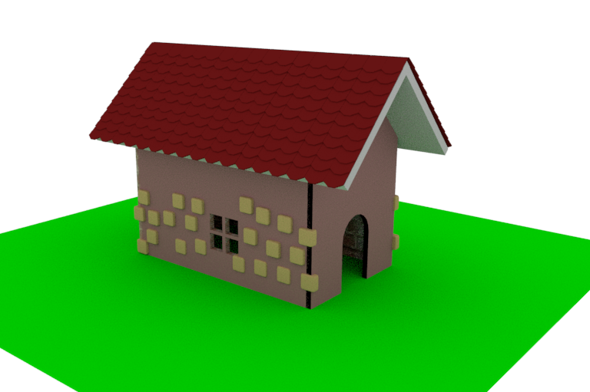

A house made be using different techniques like using primitive polygon, extrusion modeling, Skydome light is added, in order to get well rendering.

# Book

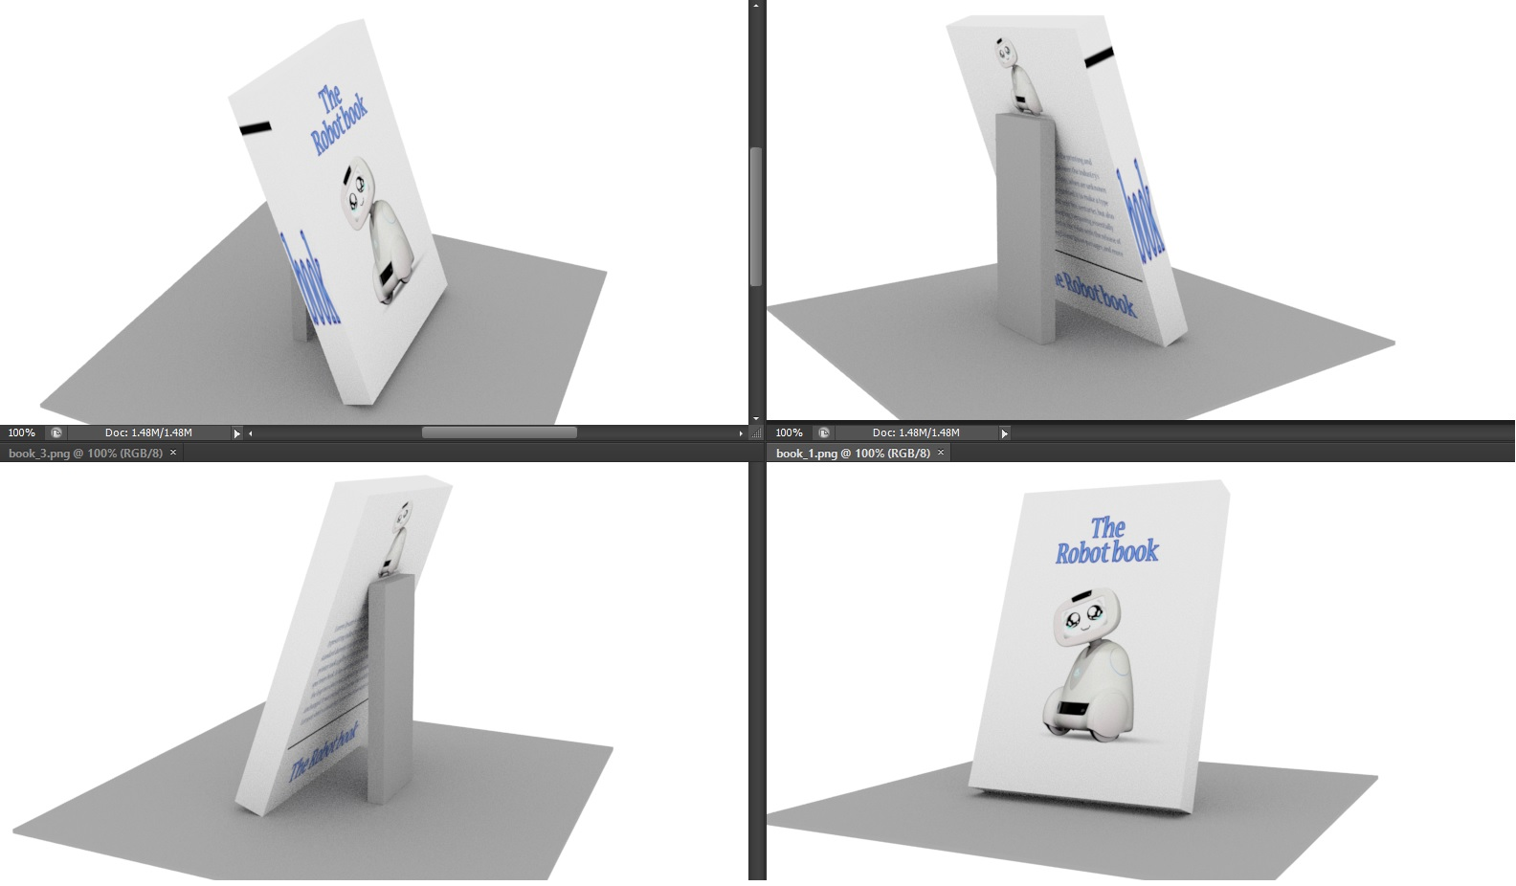

This book made of by shaping a polygon object as a book, then adding a cover as material using image, which is edited by photoshop, then adding the setting up the UV planar in order to project the material on the correct side.

# Robot

A sketch is made beforehand by pencil and paper, then the next phase it was the modeling the actual robot parts, taking into consideration the parts must be intersect together in order to avoid 3D printings fails, then export it using STL format, and after that converting it to gcode file which is the format used by 3D printer.

